Primary research for project (don't fall asleep)

For my survey I asked different types of question that related to our project, I asked my classmate and my own friends to answer my questionnaire and here where the responses.
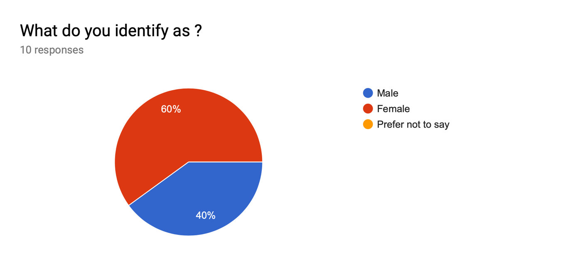
This feedback that I got from the students in my class was 60% female and 40%, male. This shows me that there are both my target audience.

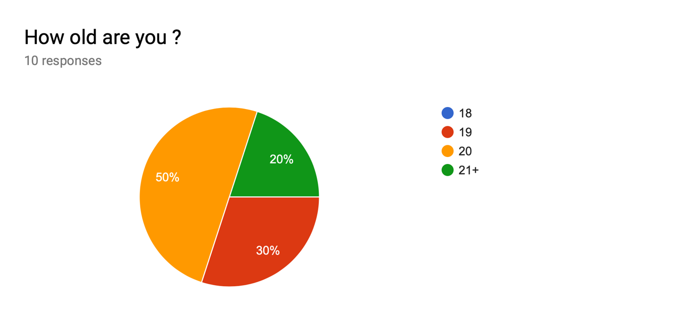
I asked the students that were in my class how old they were 50% were 20 years old, 20% were over 21 and 30% 19 years old. I can tell that my target audience is between the ages of 19 to 21.

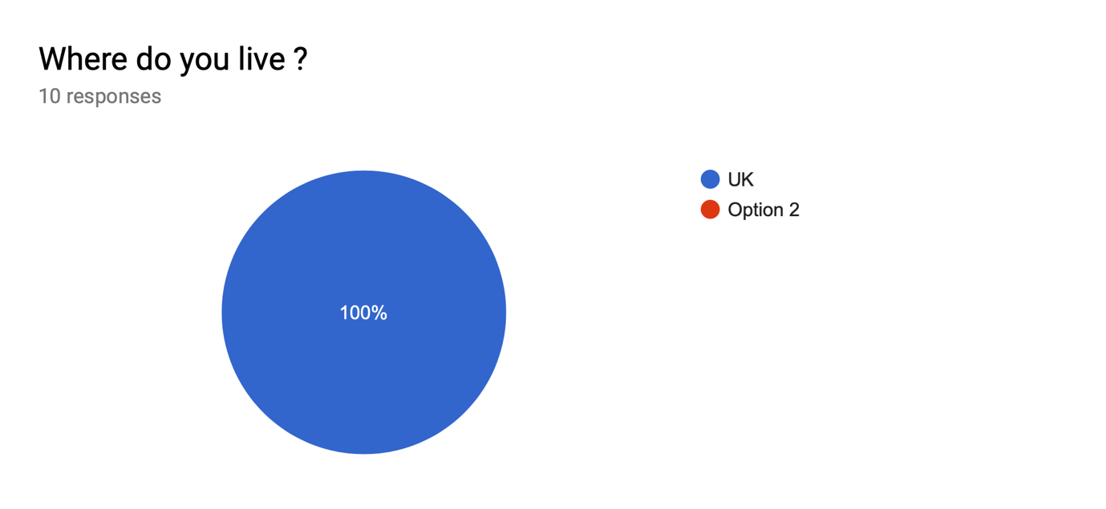
I asked the students in my class where do they live here are the responses 100% said they lived in the UK.
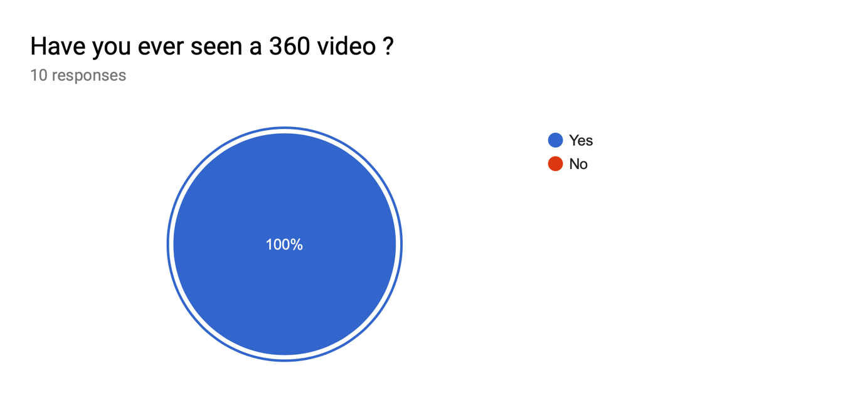
I asked the students in my class have you ever seen a 360 video before, here were the responses 100% said yes. This showed me that they were aware of what a 360 video was.

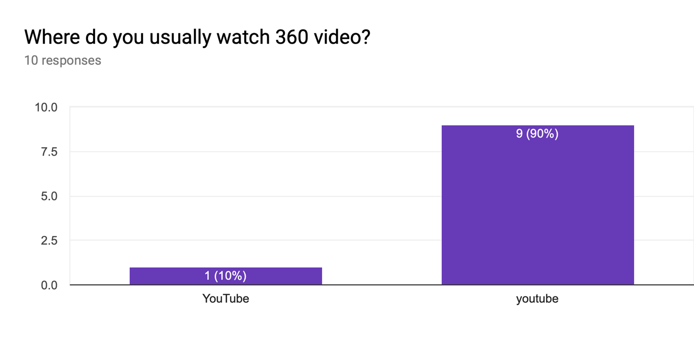
I asked where you usually watch 360 videos here are the responses 100% said YouTube. This showed me that everyone I asked watches 360 videos on YouTube as I do so it made it easier to use something, they are familiar with and that they could use easily without teaching them how to use it.
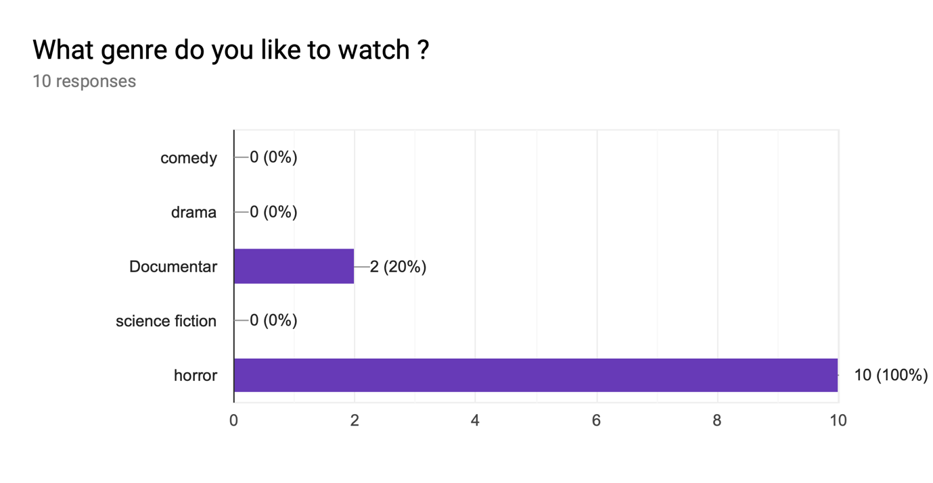
I asked what genre do you like to watch 360 videos here are the responses 20% said documentaries and 90% said horror. This showed me that each student had an interest in a 360-horror video such as myself, making it easier to know what type of things I should put in my 360 videos.
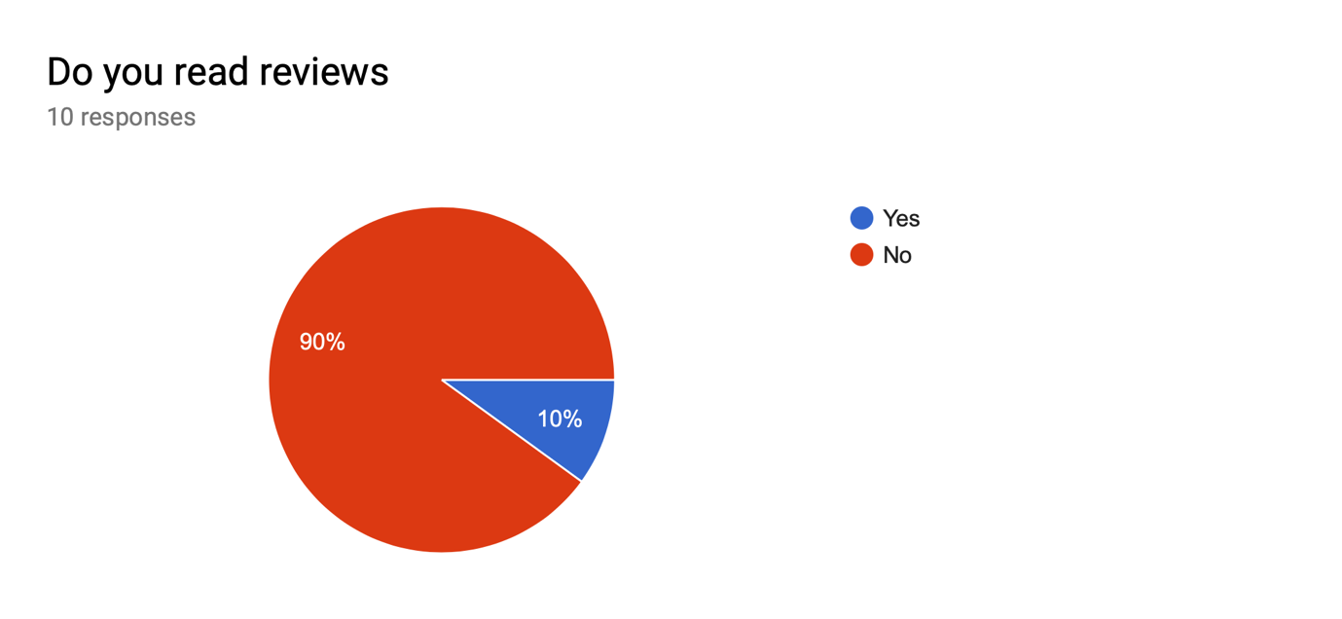
I asked do you read reviews here with the responses 90% said no and 10% said yes. This showed me that nobody reads the reviews because it’s better to have your reaction to that particular thing rather than having other people’s opinions ruin something.

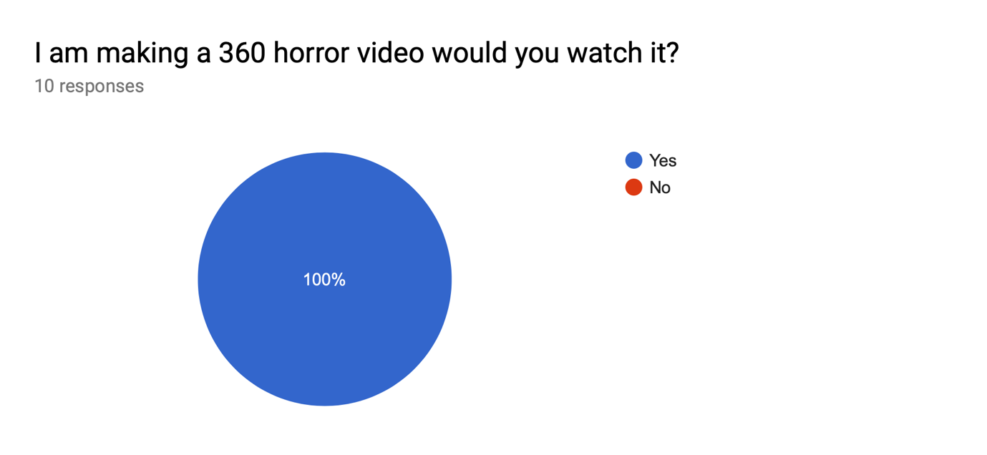

I asked the students in my class would they want to watch my group make a 360-horror video here were the responses 100% said yes. This showed me that everyone I gave the survey to wait like to see what I produce.
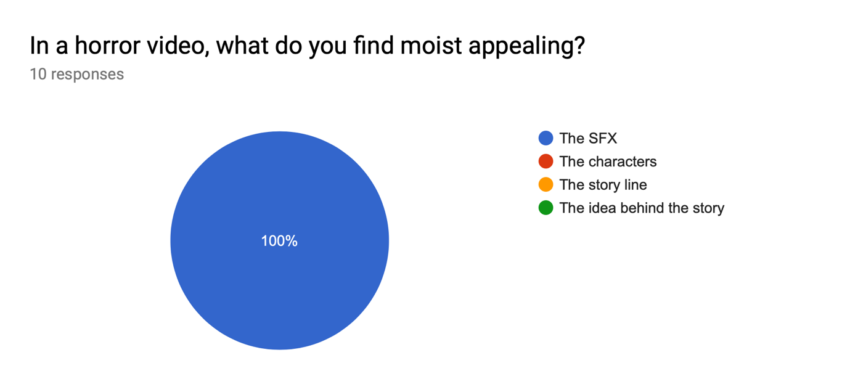

I asked in a horror video what would you find most appealing here are the responses 100% said special effects make up. This showed me that everyone wanted to see the special effects in our 360 videos.
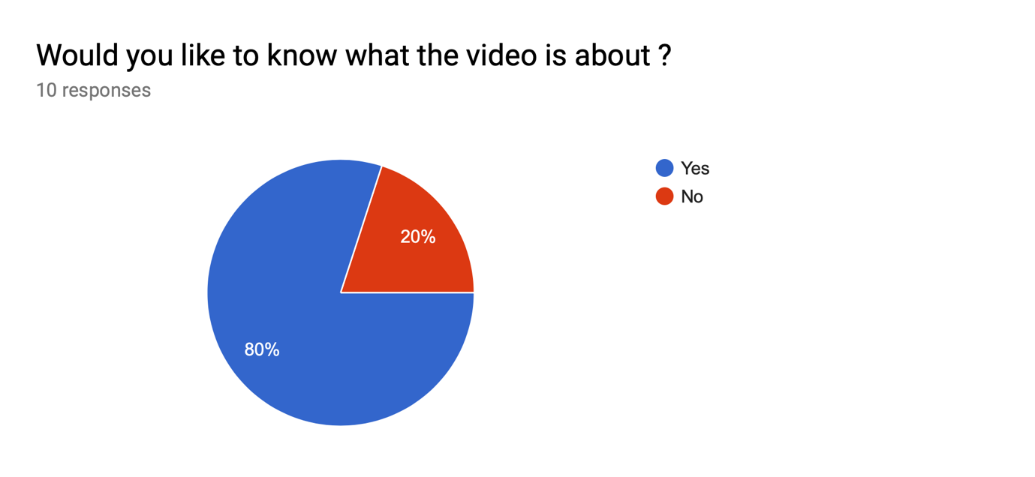
I asked would you like to know what the video is about 80% said yes and 20% said no. This showed me that people do you want to know what the 360 videos are is about and some people do not want to know what our 360 videos is about.

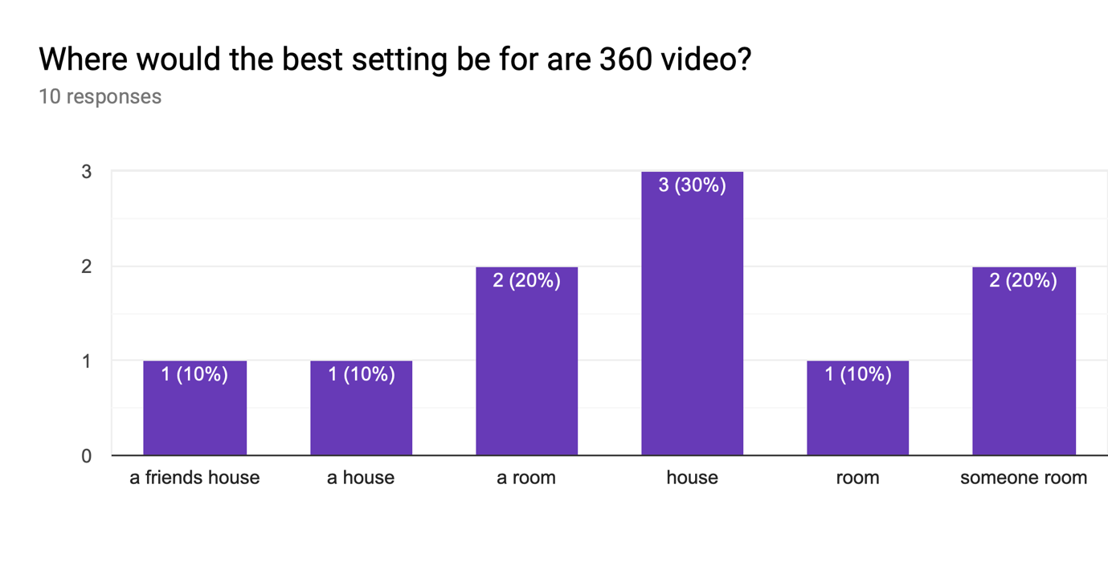

Lastly, I asked where the best setting was before or 360 videos here are the responses they were or a mixture of the same thing that was someone’s house or someone’s room.

In conclusion, analysing the feedback they have gotten from the survey has shown me that my audience is interested in what I am going to produce as a group, I will take into consideration the feedback that I have gotten and use it in our project.

